Table 11. How equilibrium is established
Beginning Equilibrium
100 mm Hg  AIR  ⇓⇓⇓⇓ | 100 mm Hg  AIR
0 mm HG  BLOOD | 100 mm Hg  BLOOD

Driving force is partial pressure

Moles  oooooooooooooooooooooooooooooooo  AIR | Moles  oooooooooooooooooooooooooooooo  AIR
BLOOD | o  BLOOD

Low solubility coefficient

Moles  oooooooooooooooooooooooooooooooo  AIR | Moles  oooooooooooooooooooooooooooooo  AIR
BLOOD | ooooooooooooooo  ooooooooooooooooooooooooooooooooooooooooooooo  BLOOD

High solubility coefficient

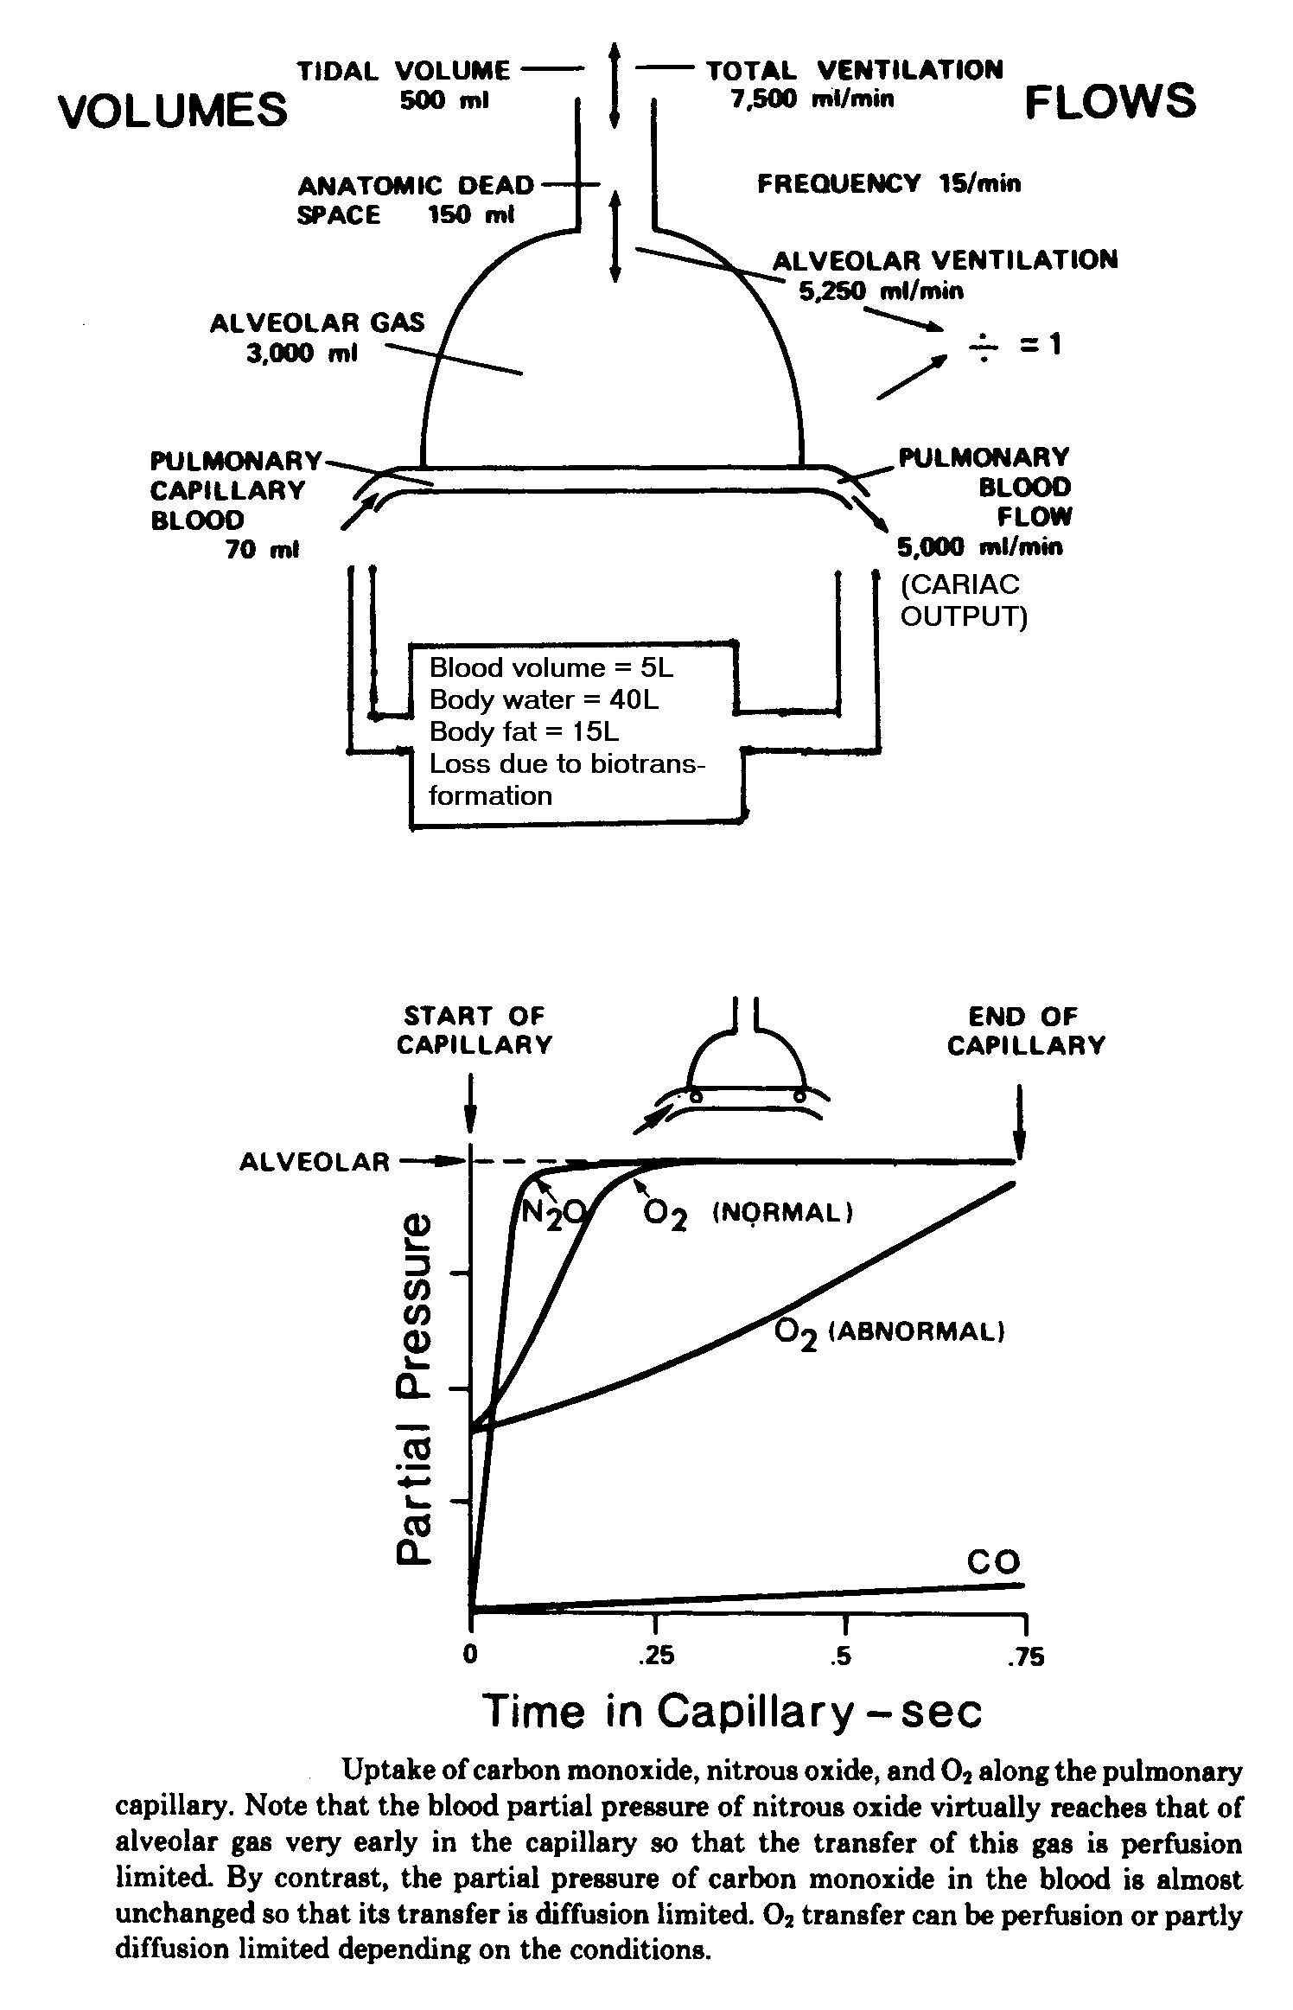

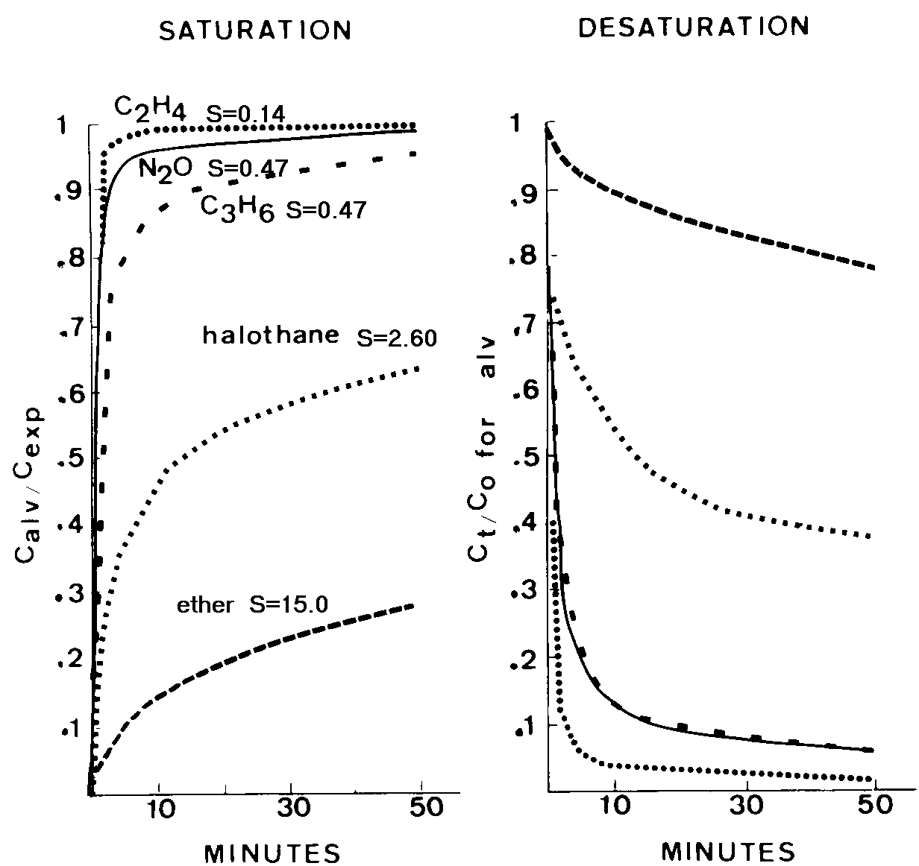

Table 12. Summary of Factors Influencing Uptake of Vapors¹

Agents | S | Concen-  tration Effect | Time To Reach Equilibrium | Quantity In Blood In mg At Equili-brium | Physiologic Factors Influencing Uptake and Time To Reach Equilibrium
Ethanol | 1,000 | Important | Slow | Large | Ventilation
Acetone | 250 | ↓ | ↓ | ↓ | ↓
Ethyl ether | 15 | ↓ | ↓ | ↓ | ↓
Benzene | 8 | ↓ | ↓ | ↓ | ↓
Chloroform | 7 | ↓ | ↓ | ↓ | ↓
Halothane | 2.5 | ↓ | ↓ | ↓ | ↓
X | 1 | ↓ | ↓ | ↓ | 50/50
Acetylene | 0.8 | ↓ | ↓ | ↓ | ↑
Nitrous oxide | 0.5 | ↓ | ↓ | ↓ | ↑
Ethylene | 0.14 | ↓ | ↓ | ↓ | ↑
Sulfur hexa-fluoride | 0.006 | Not important | Fast | Low | Cardiac Output

1

